2017 Quilts at the Creek at Black Creek Pioneer Village
Returning Vendor Application Form

Vendor Information
Black Creek Pioneer Village- 1000 Murray Ross Parkway, Toronto, Ontario
Saturday, July 29 - 11:00am - 5:00pm
Sunday, July 30 – 11:00am- 5:00pm

Quilts and quilting having always been a part of the heritage that Black Creek Pioneer Village seeks to celebrate and preserve. Be part of the tradition by applying for a spot at our sixth Annual Quilts at the
Creek event!

Vendor Selection Process
- Vendors are required to complete the vendor application form below along with a short biography.
- Staff from Black Creek will judge the applications based on acceptance criteria.
- Vendors will be notified if their applications have been accepted or declined.

Acceptance Criteria
All products will be judged on the following criteria:
- Relevance to quilting theme
- Interest to patrons
- Product uniqueness

Vendors are accepted based on the items listed and pictured on their application form. If you wish to sell items other than those listed and pictured, permission must be obtained from Black Creek Pioneer Village
PRIOR TO THE EVENT.

Vendors must provide Black Creek with the name of the person(s) staffing the booth. The booth must be staffed at all times.

Categories
At this time, Black Creek is looking primarily for craft or supplies vendors. These include vendors who create
and sell quilted crafts or items, or vendors who sell supplies or tools for the creation of quilts and
handicrafts. Vendors who wish to sell food, health beauty items, or other higher risk items must provide proof of insurance with a public liability of $5,000,000.

Vendor Information
The Quilter’s Marketplace will take place in our covered Event Pavilion. Limited electricity is available
for computers and debit/credit machines. Black Creek Pioneer Village will provide the following:
- Three (3) 6ft plastic table
- Two (2) chairs

Vendors are responsible for:
- Vendor signage
- Table décor
- Shelving to display product
- Extension cords
- Removal of personal décor and garbage. Garbage and recycling bins will be available.

Vendors may drop off equipment and merchandise on Saturday, July 29th between 8:30am and 10:45am. The
storage area will be locked overnight and supervised during open hours. Merchandise requiring
overnight storage may be placed in the secure area between 4:30pm and 6:00pm on Saturday, July
29th. Vendors must remove their merchandise and displays between 5:00pm and 6:30pm on Sunday,
July 30th. Vehicles are only permitted in the Village for set-up between 8:30am and 10:45am and
after 4:30pm. Please note that the Quilter’s Market place is directly accessible by car. Pictures of the
Event Pavilion can be viewed at http://www.blackcreek.ca/v2/private-functions/

The rental fee is $186.45 for both days and is non-refundable upon confirmation of your participation
in the market.

Rental: $165.00
HST: $21.45.
Total: $186.45

Space will be allocated on a first come first served basis. If you have additional equipment, ie free
standing walls/racks etc. that you wish to use, please indicate this on your application and include a picture if possible. For the purpose of slight lines and in fairness to all vendors; display walls over 4ft tall can only be used if you select a book that backs on to a wall.

Vendors will have their names, websites (if applicable) and images of their work displayed on the web at www.blackcreek.ca and will be listed in the event program.

Vendors who wish to bring their own tents and/ or tables – please note this on your application or call Erika Wilson at (416) 736-1733 ext. 5427.

Our Event Pavilion is located at the heart of Black Creek and is fully equipped with overhead halogen lighting to ensure a well-lit space.
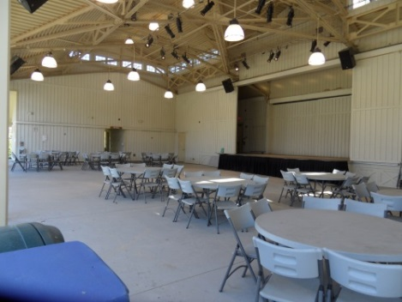
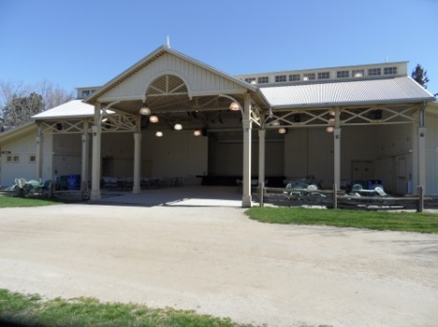

Name: _____________________________________________________
Company Name: __________________________________________________________________________

Address: ________________________________________________________________________________
City: __________________________________ Postal Code:______________________________________

Phone (Home): __________________________ Cell: ____________________________________________

Website (if applicable): _____________________________________________________________________

Electrical required? (If yes, please indicate number of plugs needed):_________________________________

Product Description(s): Attach additional documents/photos)

Please complete the above and submit by May 19th, 2017. Booths will be assigned on a first come, first serve basis and space may not be available. Applications received after May 19th may still be accepted depending on available spaces.
Applications will be reviewed as they are received. Please allow two weeks for the applications to be reviewed. All applicants will be contacted when applications are received. An application does not constitute an acceptance to vend by Black Creek Pioneer Village. Successful applicants will be asked to complete and sign a formal concession and permit agreement, a sample of which can be found on the Quilts at the Creek webpage.
Please send applications to:
Black Creek Pioneer Village
1000 Murray Ross Parkway
Toronto, ONT
M3J 2P3
Attn: Quilts at the Creek Vendor Application Form/Erika Wilson
Electronic submissions can be sent to ewilson@trca.on.ca with “Quilts at the Creek Vendor Application” as the subject.

